Last Update: April 8, 2018

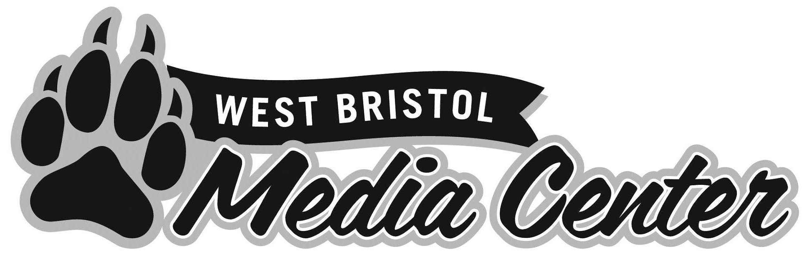
Library Policies for
Students and Teachers

Acknowledgement
The West Bristol Media Center would like to thank all the libraries that published policies on their websites. The West Bristol Media Center policies were developed in part by reviewing the existing policies of other libraries. The West Bristol Media Center policies are also based on state statutes and Bristol Board of Education policies.

Table of Contents
Introduction | 2
PBIS in the Media Center | 3
Teacher PBIS Role | 4
LMC Schedules | 5
Unscheduled Student Visits | 6
Missed Library Classes | 7
Closed for Lunch | 8
Class Book Requests | 9
Notifications PreK-5 | 10
Notifications 6-8 | 11
eMail to Students | 12
eMail to Families | 13
eMail to Homerooms | 14
Paperless Middle School | 15
Book Drop-off by Crate | 16
Equipment Checkouts | 17
Television Cart Reservations | 18
Moving Students | 19
Circulation Desk | 20
Guidelines for Library Visitors | 21
Book Care | 22
Book Checkout Rules | 23
Replacement Cost of Books | 26
Fire Drills & Yellow Folders | 27
Substitute Teachers | 28
Student Book Selection | 29
Grade 8 End of the Year Consequences | 30

The West Bristol Library Media Center provides service to a large school. West Bristol School has approximately 950 students and 100 faculty members. 42 classes visit the library on a fixed schedule. In a typical year the West Bristol School Library Media Center checks out and shelves 25,000 to 30,000 books. Additionally, the library provides many other services to the West Bristol School community. The West Bristol School Library Media Center has established the policies in this guide to provide efficient and reliable service. Patrons must adhere to the policies in this guide or they may have their library privileges limited. The West Bristol School Library Media Center welcomes any suggestions to improve library policies. Please contact the West Bristol School Library Media Center if you have recommendations to revise library policies.

PBIS in the library requires teamwork. Classroom teachers, the library assistant, the library media specialist, the students of West Bristol and all other adults that visit the library must work collaboratively to establish a climate of high behavioral standards. Using the PBIS systems approach, the West Bristol Media Center staff has developed a simple routine for class visits to the library. This routine is easily adapted to all grade levels. Every class that makes a scheduled visit to the library will follow the same routine. As students progress from grade to grade the library routine will become second nature.

Library Visit Routine:
- Students enter the library at level 0.
- Students return books to the librarian.
- Students sit at level 0.
- Librarian addresses the class.
- Classroom teacher addresses the class and hands out markers.
- Librarian calls students with overdue books and renewals to the circulation desk.
- Students with overdue books select one book from the browsing box, sit and read silently.
- Students that renewed books sit and read silently.
- All other students search for and check out books.
- All students need to be sitting and reading silently for at least the last 5 minutes of class.
- Librarian and classroom teacher address the class.
- Class makes sure the library is in order.
- Class exits at level 0.

Teachers play an important role in supervising and instructing their students in the library. The library assistant is not responsible for instructing and supervising classes. The library assistant helps the classroom teacher. The classroom teacher is responsible for supervising and instructing his/her class and enforcing library rules. Teachers must:
- remain in the library with their classes
- address their classes and remind them of library expectations
- hand out shelf markers
- move around the library and monitor their entire classes
- enforce library procedures and rules
- assist their students in finding books
Library class is not a prep period or a special. Teachers are in charge of their classes in the library. Teachers cannot bring items to work on during library time. Teachers should not correct papers or complete any other prep work during library time. Teachers must monitor and instruct their classes during library time. The library assistant is not in charge of classes.

There are several library schedules. The following schedules can be viewed on the West Bristol School Media Center webpage:
- regular preK-5 schedule
- planned early dismissal preK-5 schedule
- regular 6-8 schedule
- planned early dismissal 6-8 schedule
- 2 hour delay schedule 6-8

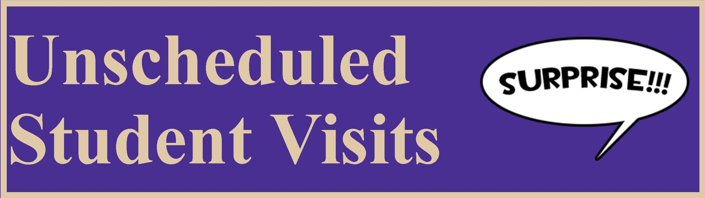
West Bristol Students are permitted to return overdue books to the library every morning from 8:15 to 8:30. During the morning, students will be seen on a first-come first-served basis. If the library is busy in the morning, students may be asked to return another day. During this time block the following students may visit the library to return overdue books:

- Students who were absent for their regularly scheduled library class.
- Students who received an overdue or lost book notification.
- All other book returns must be completed during regularly scheduled library classes.
- Students that come to the library at the wrong time will not be allowed to check out new books. They will be sent back to their class and given a reminder notice about the unscheduled library visit policy.

Sometimes, teachers/staff send students to the media center without notifying library staff. Examples of this are students looking for equipment, books, tech support etc…… Teachers and staff must inform students that they should not expect immediate service. Teachers must also inform students to be courteous and safe when making an unexpected visit. Mrs. Michaud should not be disturbed if she is teaching a class. Students should exit the library if no adult staff members are present. The best way to contact the library is by email. Setting up equipment pickups, tech training, book support and other library services should be done in advance via email. Last minute service cannot be guaranteed.

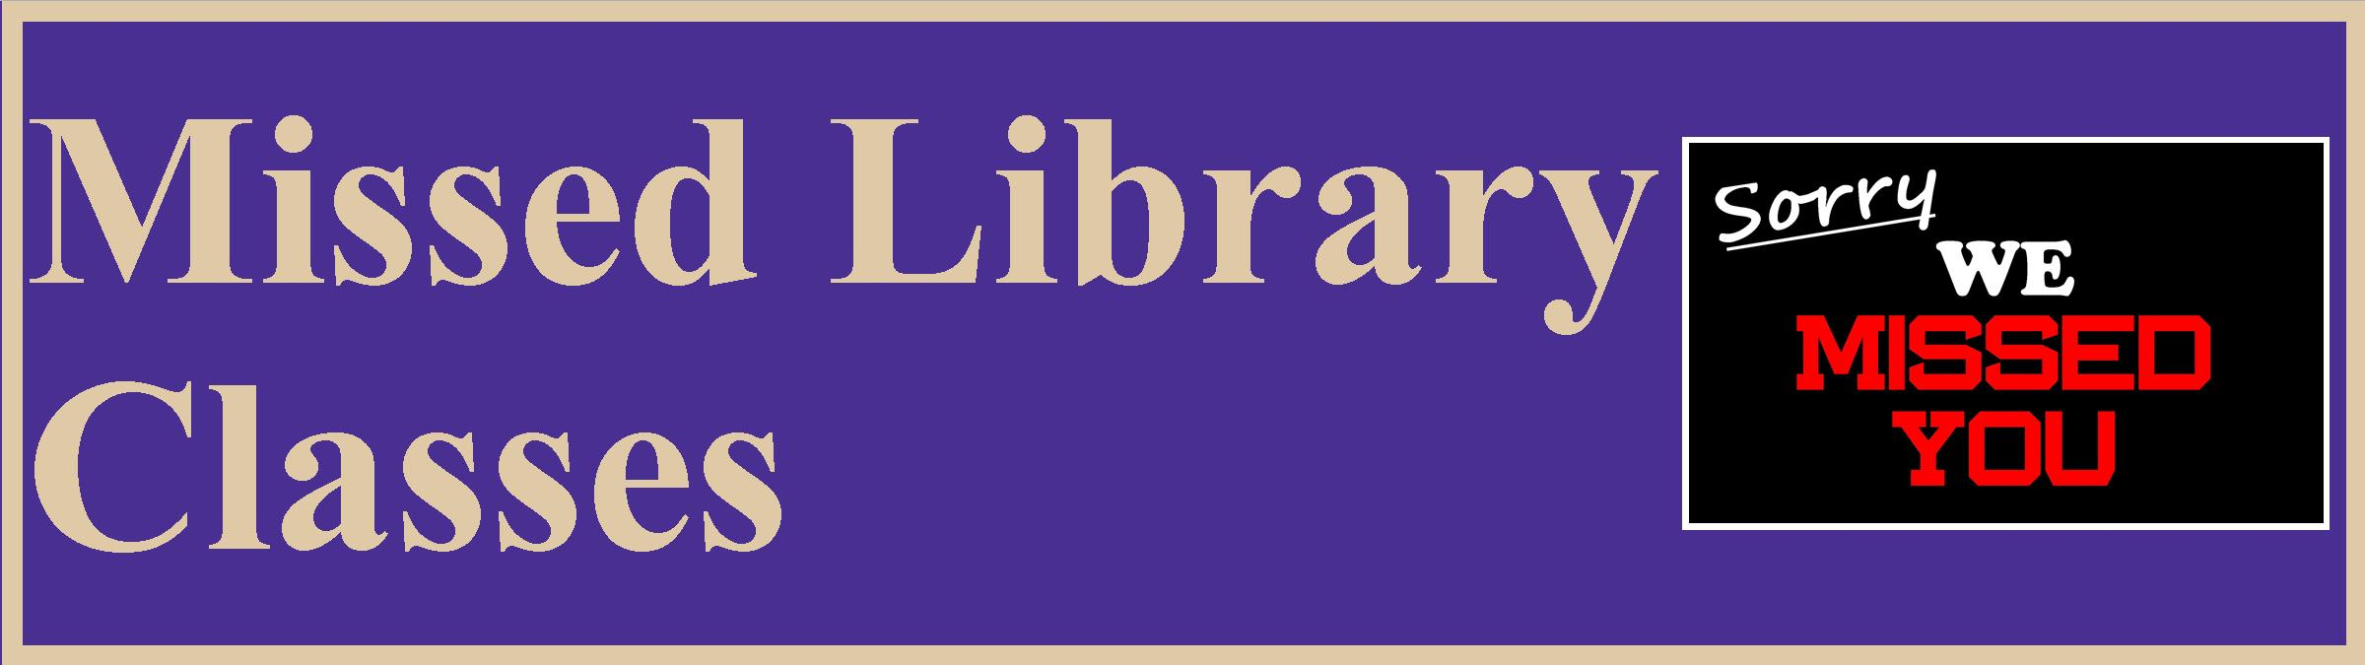
Library classes may be missed for the following reasons:
- holidays
- snow days
- library assistant absences
- late openings
- early dismissals due to weather
- field trips
- assemblies
- school events
- other circumstances

Missed Elementary Classes
Missed elementary library classes will not be rescheduled. An exception will be considered for classes that miss an excessive number of library classes.

Missed Elementary Classes Due to Special Events or Assemblies
Missed elementary library classes due to a school event or assembly will not be rescheduled. Teachers may want to contact the organizer of the event to inform them that a regularly scheduled library class will be missed. The organizer of the event might be able to change the schedule.

Elementary Library Time Swaps
If an elementary teacher is going to miss library class, they can swap library times with another teacher. It is the responsibility of the classroom teacher to setup the swap. The swap must fit exactly into the schedule and require no start or end time changes. Teachers must inform the library assistant and the library media specialist with at least one day's notice.

Late Arrivals and Early Departures
A regular library session is 30 minutes. In that 30 minutes a great deal is accomplished. If a class arrives significantly late or has to leave early, the library will only collect books and not check out books. It is too difficult to rush through an entire class.

Missed Middle School Classes
Middle school classes visit the library once every three weeks. Every effort possible will be made to reschedule missed middle school library classes. Middle school language arts teachers will need to coordinate with the library media specialist to reschedule classes. Language Arts Teachers must notify the library media specialist of any possible disruptions to the library schedule. Notifications should be given several days in advance.

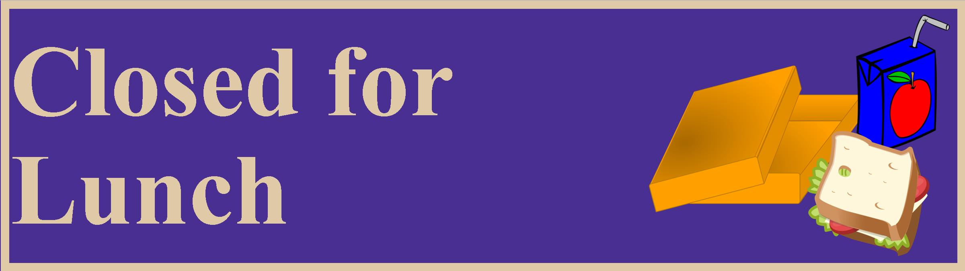
The library will close for lunch everyday. A sign will be hung on the door to indicate the library is closed. The sign will also show the time the library will reopen. Please do not disturb the library assistant during lunch.

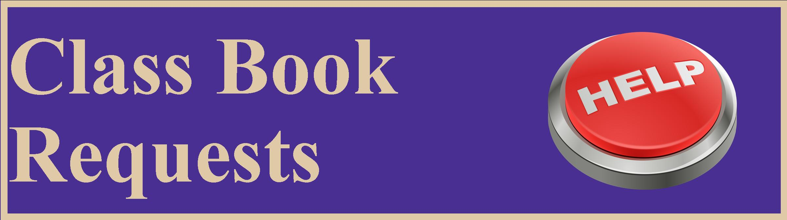
At least 3 days notice is required anytime teachers require books for their entire class. Teachers need to notify the library by completing the book request form on the West Bristol library Media Center Website. Completing the form helps the library prepare, monitor demand and purchase books. There are two types of class book request teachers can make:
- During scheduled library classes teachers may want their students to checkout a certain type of books. For example, a teacher may want all the students in the class to checkout mystery books.
- Teachers may want books from the library collection pulled and checked out in their name; for example, a teacher may request the library to pull poetry books for a classroom project.
- If a teacher is requesting a group of books, the library will notify the teacher when the group of books is ready to be picked up.

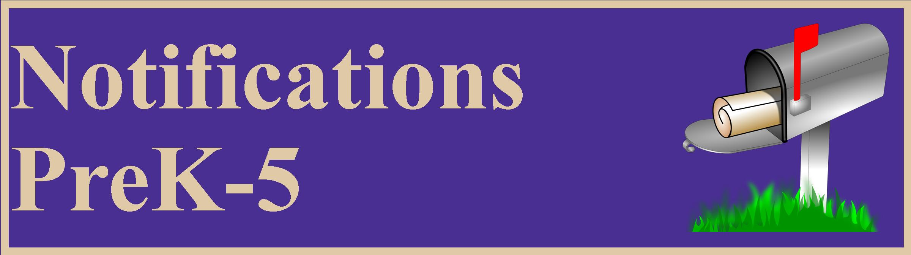
General Information
Notification of overdue or lost material is a service provided by the library. Failure to receive a notice does not free the borrower from responsibility for an overdue book. The West Bristol Media Center will attempt to provide the following forms of notification: (1) verbal reminders, (2) printed overdue notices, (3) electronic overdue notices to the email account provided to the school district, (4) electronic overdue notices to the Google school email accounts provided to students in grades 2 through grade 5 and (5) calls to the telephone numbers provided to the school district. If a person thinks he/she has received an overdue notice in error, he/she should notify the library as soon as possible. Claims of incorrect overdue notices must be made before a book is declared lost.

Information Regarding eMail Notifications
West Bristol School students in grades 2-5 will receive overdue and lost book notifications in their school Google email accounts. Parents and guardians will also receive overdue and lost book email notifications. The goal of sending email notices to parents and guardians is to make sure they are aware that their children have overdue or lost books. Parents are very helpful finding books at home and sending them back to school. Parents who believe they have received an email notification incorrectly should send a reply email. Typically, most problems can be resolved via email.

Notifications for Students in Grades PreK-1
- Verbal reminders for overdue and lost books will be given to students during each library class.
- Written notifications for overdue and lost books will be given to students during each library class.
- Email notifications will be sent to homeroom teachers so they can remind students about overdue and lost books.
- Email notifications will be sent to parents/guardians so they can make sure books are returned to the library in a timely manner.
- Students with lost books will receive notices in their report card envelopes.
Notifications for Students in Grades 2-5
- Verbal reminders for overdue and lost books will be given to students during each library class.
- Written notifications for overdue and lost books will be given to students during each library class.
- Email notifications will be sent to homeroom teachers so they can remind students about overdue and lost books.
- Email notifications will be sent to parents/guardians so they can make sure books are returned to the library in a timely manner.
- Email notifications will be sent to students' school Google email accounts.
- Students with lost books will receive notices in their report card envelopes.

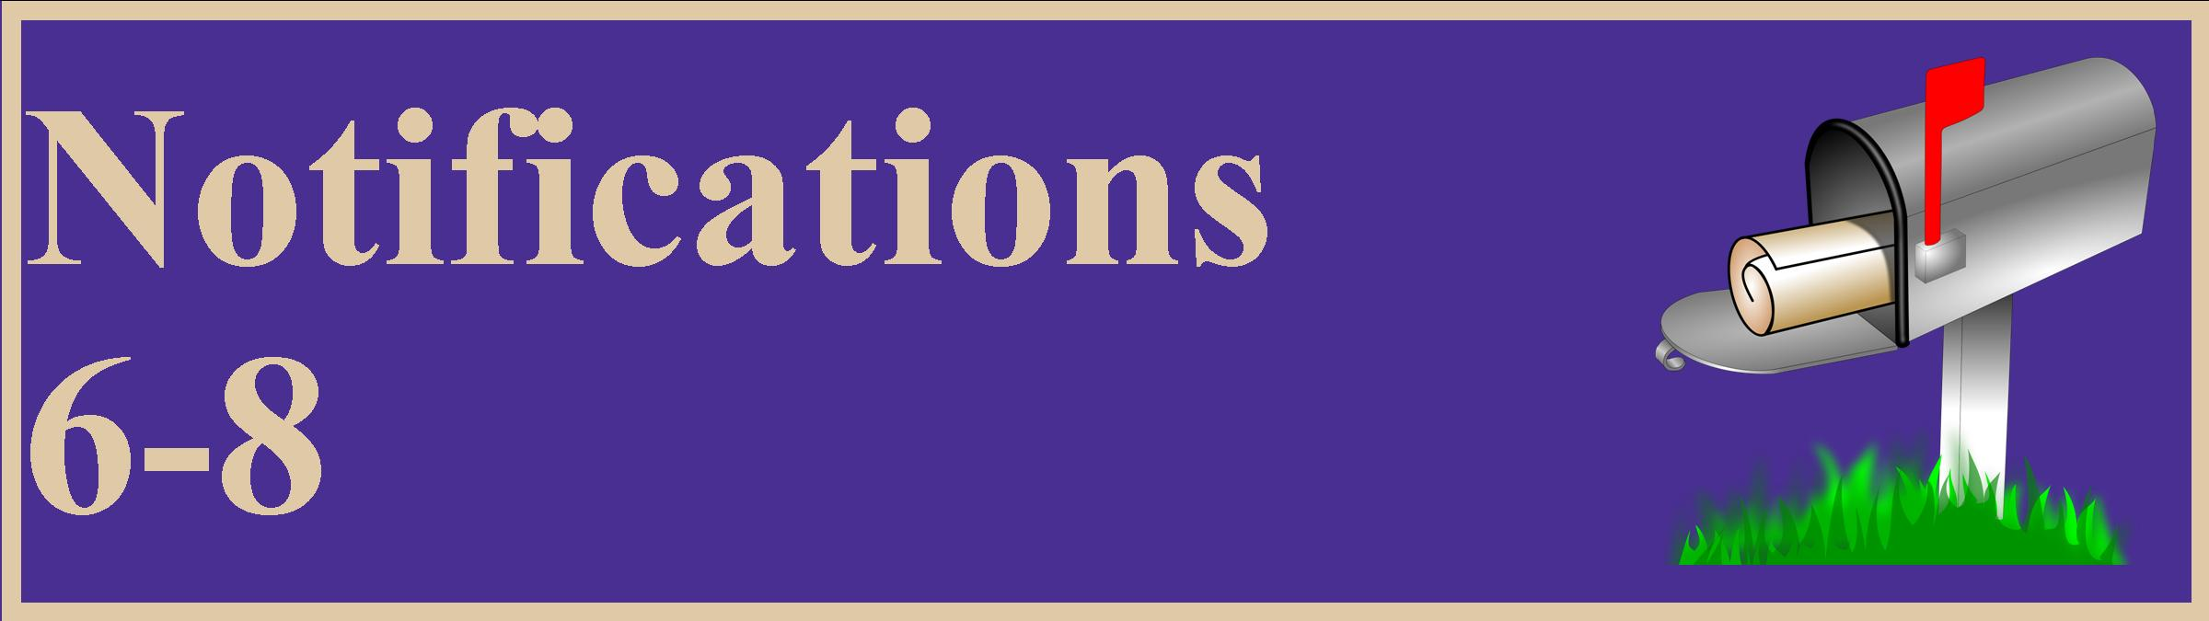
General Information
Notification of overdue or lost material is a service provided by the library. Failure to receive a notice does not free the borrower from responsibility for an overdue book. The West Bristol Media Center will attempt to provide the following forms of notification: (1) verbal reminders, (2) electronic overdue notices to the email account provided to the school district, (3) electronic overdue notices to the Google school email accounts provided to students in grades 6 through grade 8, (4)printed overdue notices and (5) calls to the telephone numbers provided to the school district. If a person thinks he/she has received an overdue notice in error he/she should notify the library as soon as possible. Claims of incorrect overdue notices must be made before a book is declared lost.

Information Regarding eMail Notifications
West Bristol School students in grades 6-8 are not guaranteed to receive paper notifications for overdue and lost books. Notifications to students will be verbal and via email. Parents and guardians will also receive email notifications for overdue and lost books. The goal of sending email notices to parents and guardians is to make sure they are aware that their children have overdue or lost books. Parents are very helpful finding books at home and sending them back to school. Parents who believe they have received an email notification incorrectly should send a reply email. Typically, most problems can be resolved via email.
Notifications for Students in Grades 6-8
- Verbal reminders for overdue and lost books will be given to students at the end of every library class.
- Written notifications for overdue and lost books may be given to students during each library class.
- Email notifications will be sent to homeroom teachers so they can remind students about overdue and lost books.
- Email notifications for overdue and lost books will be sent to parents/guardians so they can make sure items are returned to the library in a timely manner.
- Email notifications for overdue and lost books will be sent to students' school Google email accounts.
- Students with lost books will receive notices in their report card envelopes.

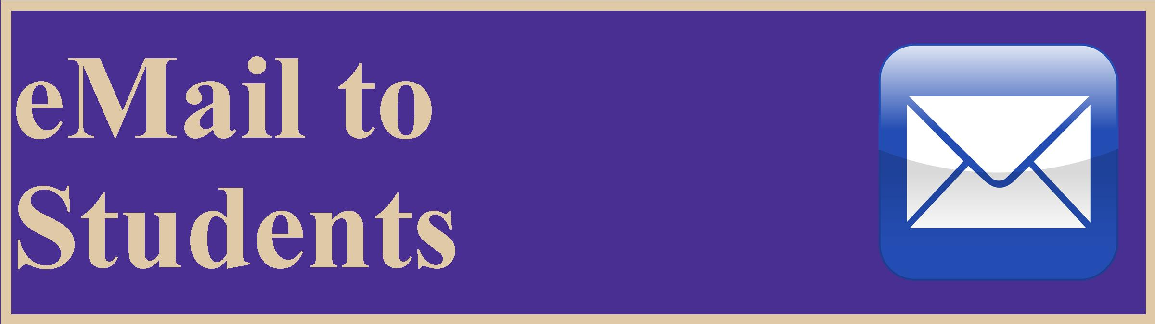
West Bristol students in grades 2-8 will receive email notifications for overdue and lost books. These email notifications will be sent to their school Google email accounts. Students are advised to check their school email accounts for notifications. Students should contact the media center if they feel they have received an incorrect notification. The best time for a student to discuss a notification problem is during their regularly scheduled library class. Students can also visit the library any morning from 8:15 - 8:30 to discuss an problem with a notification.

Parents and guardians will receive email notifications for student overdue and lost books. These email notices will be sent to email accounts provided to the school. The goals of these emails are to:
- Make sure parents are aware that their children have overdue or lost books. Parents are very helpful finding books at home and sending them back to school.
- To improve communication between home and school.

Occasionally a parent/guardian may receive an incorrect notification. Usually this will happen because a regularly scheduled library class was canceled. Parents who believe they have received an incorrect notification should send a reply email. The West Bristol Media Center appreciates your support.

Every Monday morning an email will be sent to each middle school homeroom teacher. Every Thursday morning an email will be sent to each elementary school homeroom teacher. The subject of the emails will be Weekly eMail to Homeroom Teachers. The email will have an attachment. The attachment contains the names of any students in the teacher's homeroom who have overdue or lost books. The West Bristol Media Center requests that each homeroom teacher open the attachment and share the information with his/her homeroom students. Please remember that students may visit the library any morning from 8:15 - 8:30 to return overdue or lost books. Homeroom teachers should notify the West Bristol Media Center if they notice a problem with the information on the attachment.

For the 2016-2017 school year, the West Bristol Media Center will use a paperless notification system for middle school patrons. All middle school notifications will be sent via email. Notifications for overdue and lost books will be sent to parent/guardian email accounts and to student Google email accounts. Students are advised to monitor their school email accounts for library notifications. Patrons should disregard overdue and lost book notifications if their regularly scheduled library class was canceled because school was closed, opened late or dismissed early. Patrons who feel they have received an email notification in error should reply to the email and state their concerns.

Elementary
On library class day some teachers prefer to return their students' library books prior to visiting the media center. The media center has crates which can be used to transport library books from the classroom to the media center. On their scheduled library visit day teachers can stop by in the morning to pick up crates or send a couple of students between 8:15 and 8:30. Library books can be heavy and it is safer to use more than one crate to deliver a set of books from an entire class. Load books into the crates carefully. Books that are carelessly loaded into crates can be damaged.

Middle School
Middle school classes cannot use crates to return books to the library. Middle school students must return their books at the time of their scheduled library classes.

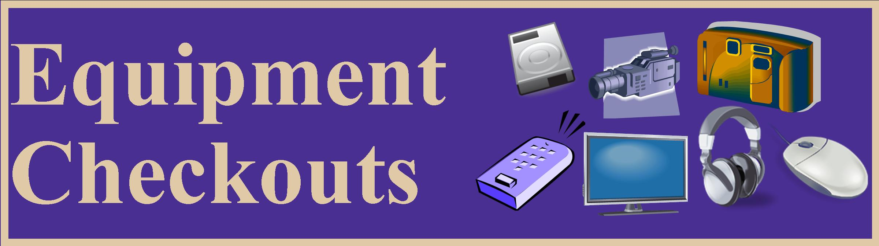
Members of the West Bristol staff can check out equipment from the West Bristol Media Center. Staff members must give 2 days notice when requesting equipment. Notice must be given because equipment is not stored in the library. To check out equipment staff members should follow these steps:

- Teachers can use the West Bristol Equipment List to browse for equipment and make sure it is available for checkout. The West Bristol Equipment List is located on WB21 Help Desk.
- Teachers must email their equipment request to Mr. Russo at least two days prior to the planned checkout date.
- The email must include the name of the equipment to be checked out. Teachers should copy and paste the name of the equipment from the West Bristol Equipment List. Teachers must also include the pickup date.
- Teachers will get an email notifying them that their equipment is ready to be picked up. The equipment will be located at the circulation desk.

To view the equipment check out tutorial, please visit the equipment webpage on the WB21 Help Desk Website.

The television cart is like a library book; it is checked out and has a due date. To reserve the television cart please email Mr. Russo. If you are reserving the television cart for a substitute teacher, make sure you pick the cart up the day before your substitute will be in your class. The media center is not responsible for delivering or picking up the television cart. Students are not permitted to transport the television cart. You might have to check the Television Cart Reservation Calendar to determine which teacher has the television cart. To view the Television Cart Reservation Calendar, please visit the television cart reservation webpage.

It is extremely difficult for the library to guarantee television cart reservations. The library media center cannot ensure that faculty patrons will return the television cart in a timely manner. For that reason, it is prudent to leave substitutes back-up plans that do not require the use of the television.

Every year the library loses many items because students move without returning their books. Please inform the library if you learn a student in your class will be moving. The library will work to get the books back before the student moves.

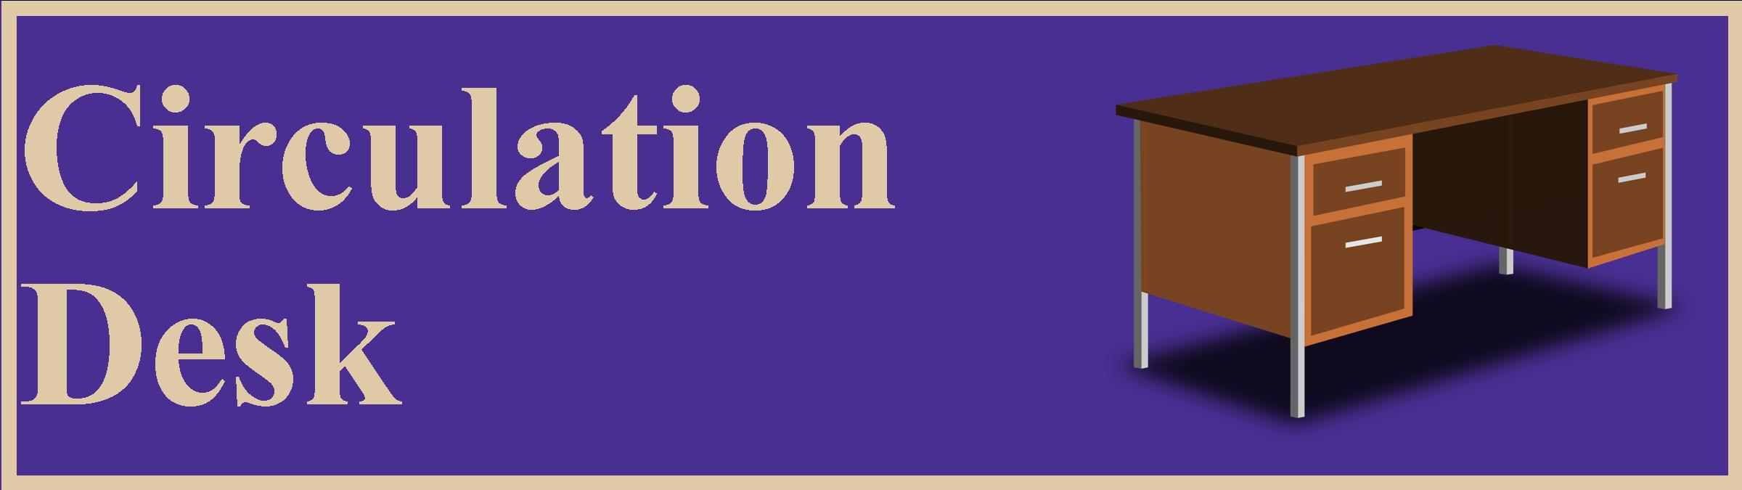
The circulation desk is for library staff only; it is the professional/personal work space of the library assistant. This area has confidential information and must remain secure. Please do not enter the area behind the circulation desk.

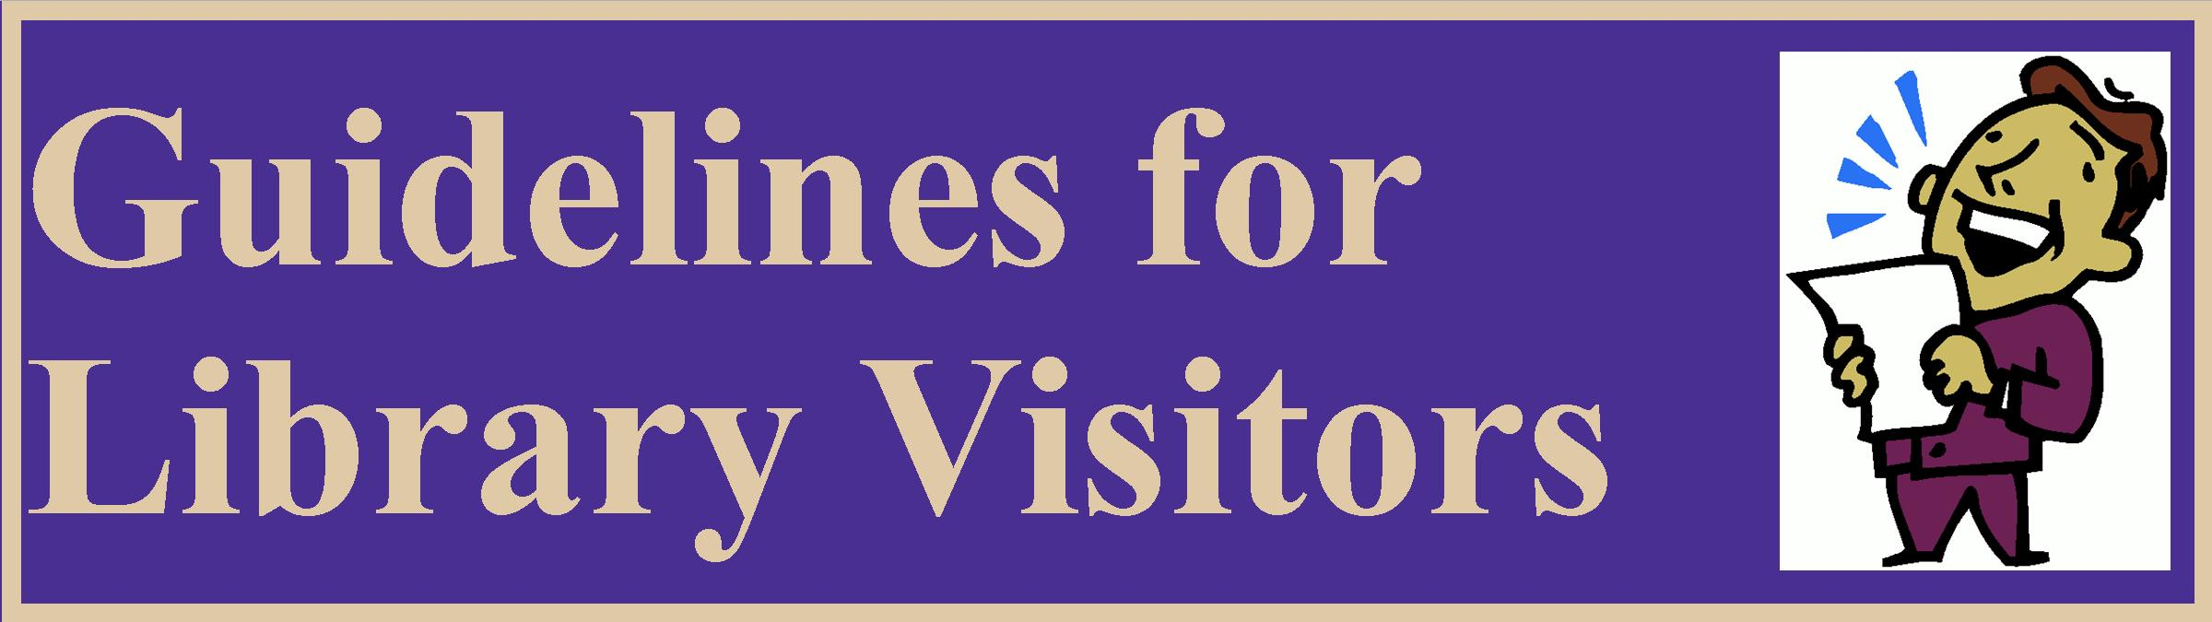
The West Bristol Media Center welcomes all members of the West Bristol School community. The West Bristol Media Center staff works diligently to provide all its patrons a pleasant library experience in an atmosphere conducive to learning. The Library staff’s main priority is to provide service to the 42 classes in grades preK through 8 that visit the library on a regular schedule. Other groups may use the library, but visitors must remember to act appropriately in the media center. The following guidelines for library visitors support student safety and an environment conducive to learning:
- Do not interfere with scheduled library classes.
- If you are working with a group of students pick a section of the library that is quiet.
- If you are working with a group of students do not leave them unsupervised.
- If you are supervising a group of students make sure they follow the established PBIS rules for behavior in the library.
- Make sure the library is kept neat and orderly.
- If you move any furniture, you must return it to its original location.
- Push in all chairs.
- Adults must yield computers to students in need; the main purpose of the library computers is for students to search for books.
- Under most circumstances, the library media center staff will not reserve library space for visitors.

Please remember that the library staff is responsible for maintaining the library. The library staff dusts the shelves, vacuums the rugs, polishes the furniture, straightens out all areas of the library and repairs all cases of vandalism. Guests that do not adhere to the visitor guidelines will be reported to the school administration.

After school events in the library must be approved by the school administration. The library staff prefers that after school activities be scheduled for areas other than the library.

Please follow these guidelines to ensure the safety of your library books:
- Consider keeping books in a special place so they can always be located (some students leave their books in their lockers).
- Do not store items that can spill in the same backpack compartment as the book.
- Don't let people borrow library books.
- Don't leave books outside or in the car.
- Always use a bookmark or piece of paper to mark your page.
- Do not use thick bookmarks.
- Never fold down the page corners as bookmarks.
- Do not leave a book open flat face down on a table.
- Protect books from the weather, especially if they are too big to fit in a backpack.
- Do not eat or drink near a library book.
- Do not color, cut pictures or highlight words in a library book.
- Do not take books into the bathroom.
- Be careful if you leave your library book in a teacher’s return bin. Quite often, books are damaged or stolen from teacher’s return bins. Students are responsible for the book(s) they checked out, even if the book is stolen from or damaged in a teacher’s book return bin.
- Keep library books out of reach from babies, toddlers and pets.
- Do not attach post it notes to the pages of library books.
- Make sure all items are removed from a book before it is returned.

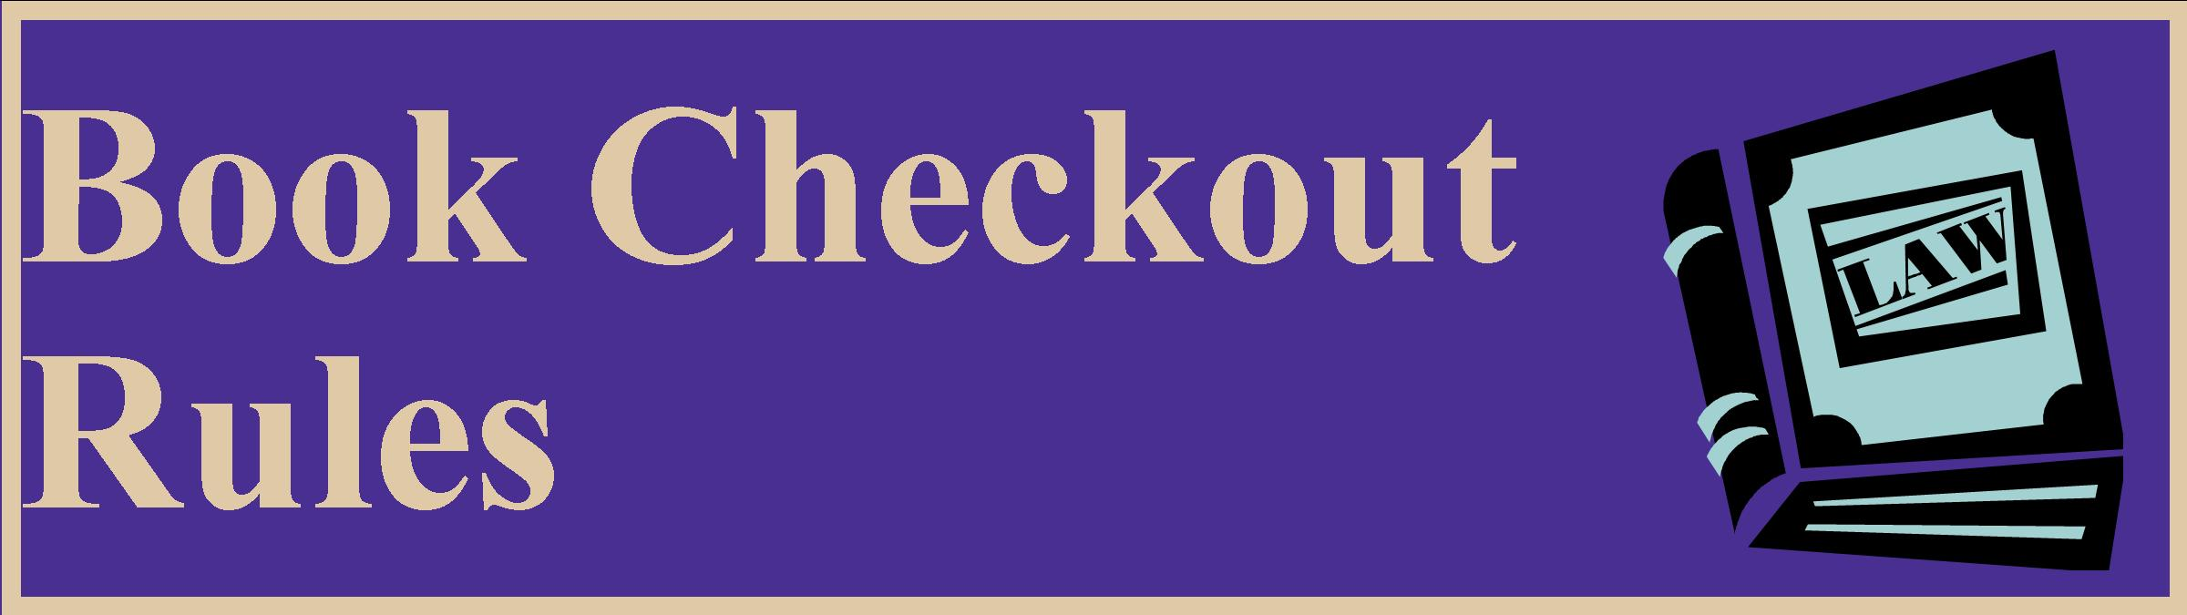
Introduction
All borrowers, including West Bristol School faculty and staff, are expected to adhere to these policies. These policies do not include eBooks. The West Bristol Media Center attempts to instill in our patrons a sense of responsibility for the books they borrow. Patrons of the West Bristol Media Center are required to take care of the books they check out and make sure they are returned on time so other patrons may borrow them. These policies must be followed in order to ensure that all patrons of the West Bristol Media Center have access to quality books.

Book Borrowing Limits
- Students in grades preK to grade 5 may check out 1 book at a time. The checkout period for these books is 7 days. After 7 days the books are overdue.
- Students in grade 6 to grade 8 may check out 2 books at a time. The checkout period for these books is 21 days. After 21 days the books are overdue.
- Faculty and staff may check out an unlimited number of books. The checkout period for these books is 14 days. After 14 days the books are overdue.

Renewals
- Students in grades preK to grade 5 may extend the checkout period of their book by renewing it. The book has to be brought to the library to renew it.
- Students in grades 6 to grade 8 may extend the checkout period of their book by renewing it. The book has to be brought to the library to renew it.
- Faculty may extend the checkout period of a book by renewing it. Faculty are allowed unlimited renewals.

Returning Books
Students are expected to return their books during their regularly scheduled library class. Students who do not return their book(s) during their regularly scheduled library class and students who are absent that day will receive an overdue notice. Students who receive overdue notices can make an unscheduled visit to the library to return their book(s). These visits are permitted Monday through Friday from 8:15 am to 8:30 am. Once a student has returned all his/her overdue books they will be able to check out new books.
Overdue Books
The West Bristol Media Center does not charge fines for overdue books; however, it is important that books are returned in a timely manner. Students may return overdue books any morning from 8:15 am to 8:30 am.

Notifications
Notification of overdue or lost material is a service provided by the library. Failure to receive a notice does not free the borrower of responsibility for an overdue book. The West Bristol Media Center may attempt the following forms of notification; (1) verbal reminders, (2) printed overdue notices, (3) electronic overdue notices in the email account provided to the school district, (4) electronic overdue notices in the Google school email accounts provided to students in grades 2 to grade 8 and (5) calls to the telephone numbers provided to the school district. If a person thinks they have received an overdue notice in error they should contact the media center as soon as possible. Claims of incorrect overdue notices must be made before a book is declared lost and a bill is generated.

Middle School Students Lost Books
Once a book is overdue for 5 days it is declared lost and a bill is generated. At that time the patron's account is limited and they are not allowed to check out books. Once the book is returned or paid for all library privileges are restored to the patron. Please keep in mind that each year library media centers in the Bristol Public School District incur substantial costs replacing books lost by students, faculty and staff. In order to maintain the quality of service for all patrons, it is necessary for lost books to be paid for and replaced.

Elementary School Students Lost Books
Once a book is overdue for 19 days it is declared lost and a bill is generated. At that time the patron's account is limited and they are not allowed to check out books. Once the book is returned or paid for all library privileges are restored to the patron. Please keep in mind that each year library media centers in the Bristol Public School District incur substantial costs replacing books lost by students, faculty and staff. In order to maintain the quality of service for all patrons, it is necessary for lost books to be paid for and replaced.

Faculty Lost Books
Books that are significantly overdue will be declared lost and a bill will be generated. Faculty members should not check out books from the library and loan the books to students or faculty members. At the end of the year teachers are expected to pay for all lost or damaged books associated with their library account.

Damaged Books
During a book checkout the circulation attendant will attempt to identify any existing book damage. Patrons should also check the condition of a book before they check it out. Notifying the circulation attendant about any book damage will allow the patron to avoid any monetary responsibility. When a book is returned to the library in a damaged condition, the library assistant and the library media specialist will try to determine the cause of the damage. If the book is not able to be repaired the responsible patron will be billed for the item. Patrons are advised to take care of their library books by avoiding some of the most common ways books are damaged; (1) pets, (2) babies and toddlers, (3) food, (4) liquids and (5) aggressive page turning. If library materials are willfully damaged, the offending student will be referred to school administration for disciplinary action. Students that owe payment for a damaged book will have their library account limited and will not be allowed to check out books. Patrons are asked to return damaged books to the library. The library can determine if the book can be repaired or if the book needs to be replaced.

Payments
Payments for lost or damaged books need to be made in cash or by check. Checks need to be made out to West Bristol School. Please note that the library cannot accept used or new copies of books to replace lost or damaged books. Library books are purchased with heavy duty bindings to make them more durable for constant long-term use. For this reason, the West Bristol Media Center will only accept cash or check payments for the replacement of lost or damaged books. The library reserves the right to determine how the lost or damaged item will be replaced.

Refunds for Found Books
Refunds will be handled on a case by case basis. The deciding factor in processing a refund is whether or not the money has been spent on a replacement item. Typically, patrons have 30 days to receive a refund if they find an item they paid for.

Hardships
If a student cannot pay for their lost or damaged book, a teacher, parent or guardian can discuss the matter with a school administrator.

Limited Privilege Students
Any students that owes payment for lost or damaged books will have their library privileges limited. Students with limited privileges will not be allowed to check out any books. Teachers may not check out books for students with limited library privileges. Teachers, parents and guardians may appeal the status of a student with limited library privileges. School administrators will hear all appeals. Students with limited privileges will still be able to access eBooks and view books in the library browsing box.

Payments for lost or damaged books can be made in cash or by check. Checks need to be made out to West Bristol School. Please note that the library cannot accept used or new copies of lost or damaged items in place of paying for the replacement cost. Library books are purchased with heavy duty bindings to make them more durable for heavy use. For this reason, the West Bristol Media Center will only accept cash or check payments for the replacement of lost or damaged books. The price listed on the notification is just an estimate. Prior to payment, the actual replacement cost for the book will be determined. The library reserves the right to determine how the lost or damaged item will be replaced.

Teachers must bring their yellow folders when they take their classes to the media center.

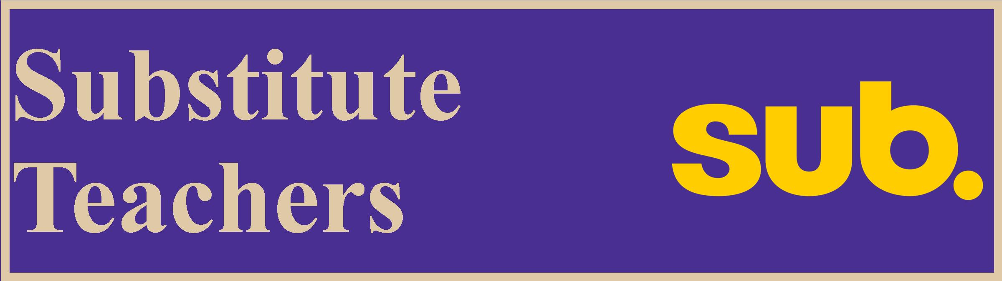
Please make sure substitute teachers know the following:
- Substitute teachers must remain with their classes during library time.
- Substitute teachers are responsible for supervising their classes during library time.

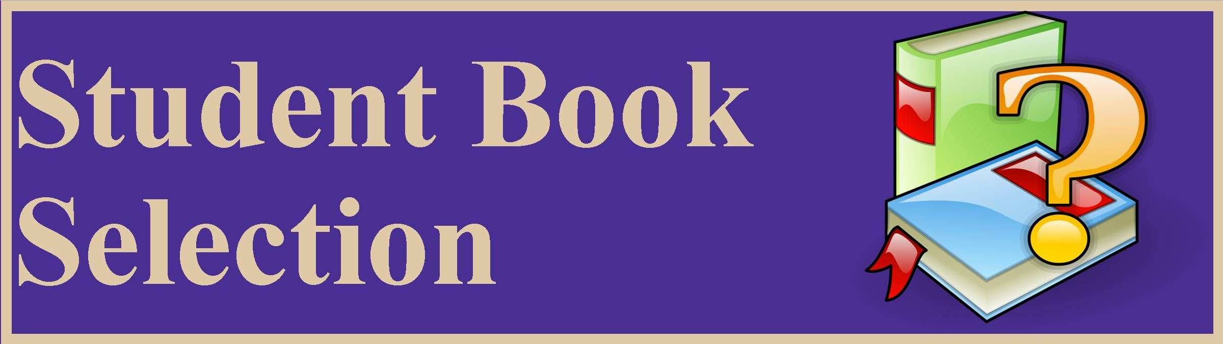
The West Bristol Media Center has thousands of books. The West Bristol Library Media Center tries to ensure that students check out books that contain appropriate content. Parents/guardians may object to a book checked out by a student. Parents/guardians are encouraged to contact the West Bristol Media Center if they have concerns regarding a book checked out by a student. Sometimes a teacher may override a library staff member and allow a student to check out a book. In those cases the teacher will assume responsibility for allowing the student to check out the book.

Grade 8 students need to pay all fees owed to the West Bristol School Media Center before they graduate. Students that have not settled their accounts with the West Bristol Media Center will have the following consequences:
- report cards withheld
- yearbooks withheld
- exclusion from year end events such as the grade 8 dance and the grade 8 field trips
- other consequences

Links for email reminders to teachers (for library staff use)

PBIS in the Media Center | https://docs.google.com/document/d/1jPZjUg5qy5oqJHqVcvUbIWHH1sQwzwf5BeiCpN7nhHc/edit#bookmark=id.s27f9fgnps9g
Teacher PBIS Role | https://docs.google.com/document/d/1jPZjUg5qy5oqJHqVcvUbIWHH1sQwzwf5BeiCpN7nhHc/edit#bookmark=id.okia7nnq0ur7
LMC Schedules | https://docs.google.com/document/d/1jPZjUg5qy5oqJHqVcvUbIWHH1sQwzwf5BeiCpN7nhHc/edit#bookmark=id.uilrgkqymxkx
Unscheduled Student Visits | https://docs.google.com/document/d/1jPZjUg5qy5oqJHqVcvUbIWHH1sQwzwf5BeiCpN7nhHc/edit#bookmark=id.yrzf453jey3s
Missed Library Classes | https://docs.google.com/document/d/1jPZjUg5qy5oqJHqVcvUbIWHH1sQwzwf5BeiCpN7nhHc/edit#bookmark=id.p7oi22emsuxx
Closed for Lunch | https://docs.google.com/document/d/1jPZjUg5qy5oqJHqVcvUbIWHH1sQwzwf5BeiCpN7nhHc/edit#bookmark=id.8jq4b5vac1vk
Class Book Requests | https://docs.google.com/document/d/1jPZjUg5qy5oqJHqVcvUbIWHH1sQwzwf5BeiCpN7nhHc/edit#bookmark=id.r1hdjice6n3l
Notifications PreK-5 | https://docs.google.com/document/d/1jPZjUg5qy5oqJHqVcvUbIWHH1sQwzwf5BeiCpN7nhHc/edit#bookmark=id.rl1tcqekrg4w
Notifications 6-8 | https://docs.google.com/document/d/1jPZjUg5qy5oqJHqVcvUbIWHH1sQwzwf5BeiCpN7nhHc/edit#bookmark=id.rrd7yjbvesec
eMail to Students | https://docs.google.com/document/d/1jPZjUg5qy5oqJHqVcvUbIWHH1sQwzwf5BeiCpN7nhHc/edit#bookmark=id.ekyj25lbs9h9
eMail to Families | https://docs.google.com/document/d/1jPZjUg5qy5oqJHqVcvUbIWHH1sQwzwf5BeiCpN7nhHc/edit#bookmark=id.qmvmswej367d
eMail to Homerooms | https://docs.google.com/document/d/1jPZjUg5qy5oqJHqVcvUbIWHH1sQwzwf5BeiCpN7nhHc/edit#bookmark=id.siczmd5oc84t
Paperless Middle School | https://docs.google.com/document/d/1jPZjUg5qy5oqJHqVcvUbIWHH1sQwzwf5BeiCpN7nhHc/edit#bookmark=id.7rwvzykg948e
Book Drop-off by Crate | https://docs.google.com/document/d/1jPZjUg5qy5oqJHqVcvUbIWHH1sQwzwf5BeiCpN7nhHc/edit#bookmark=id.y0j5ru7cclwh
Equipment Checkouts | https://docs.google.com/document/d/1jPZjUg5qy5oqJHqVcvUbIWHH1sQwzwf5BeiCpN7nhHc/edit#bookmark=id.bppuahls2mv5
Television Cart Reservations | https://docs.google.com/document/d/1jPZjUg5qy5oqJHqVcvUbIWHH1sQwzwf5BeiCpN7nhHc/edit#bookmark=id.cj8gzmuxda5x
Moving Students | https://docs.google.com/document/d/1jPZjUg5qy5oqJHqVcvUbIWHH1sQwzwf5BeiCpN7nhHc/edit#bookmark=id.vgj4kpp90npo
Circulation Desk | https://docs.google.com/document/d/1jPZjUg5qy5oqJHqVcvUbIWHH1sQwzwf5BeiCpN7nhHc/edit#bookmark=id.u2ihm26j9226
Guidelines for Library Visitors | https://docs.google.com/document/d/1jPZjUg5qy5oqJHqVcvUbIWHH1sQwzwf5BeiCpN7nhHc/edit#bookmark=id.p4xaq9ppwvq
Book Care | https://docs.google.com/document/d/1jPZjUg5qy5oqJHqVcvUbIWHH1sQwzwf5BeiCpN7nhHc/edit#bookmark=id.pkpxxve05xp
Book Checkout Rules | https://docs.google.com/document/d/1jPZjUg5qy5oqJHqVcvUbIWHH1sQwzwf5BeiCpN7nhHc/edit#bookmark=id.v3e1j95nxsd
Replacement Cost of Books | https://docs.google.com/document/d/1jPZjUg5qy5oqJHqVcvUbIWHH1sQwzwf5BeiCpN7nhHc/edit#bookmark=id.5gu2ger13iif
Fire Drills & Yellow Folders | https://docs.google.com/document/d/1jPZjUg5qy5oqJHqVcvUbIWHH1sQwzwf5BeiCpN7nhHc/edit#bookmark=id.fs4392ewce5s
Substitute Teachers | https://docs.google.com/document/d/1jPZjUg5qy5oqJHqVcvUbIWHH1sQwzwf5BeiCpN7nhHc/edit#bookmark=id.t3gk3ti7585x
Student Book Selection | https://docs.google.com/document/d/1jPZjUg5qy5oqJHqVcvUbIWHH1sQwzwf5BeiCpN7nhHc/edit#bookmark=id.b7tw1hd97np2
Grade 8 End of the Year Consequences | https://docs.google.com/document/d/1jPZjUg5qy5oqJHqVcvUbIWHH1sQwzwf5BeiCpN7nhHc/edit#bookmark=id.o2iftxlf9lnl

